Steven Thaw

sjthaw@me.com

Abstract

A Java program which adds a GUI to Project 1, allowing 2D shapes to be drawn to scale and 3D shapes to have an image displayed of that shape

CMSC 335 Object Oriented and concurrent programming

Project 2

**UML Class Diagram**

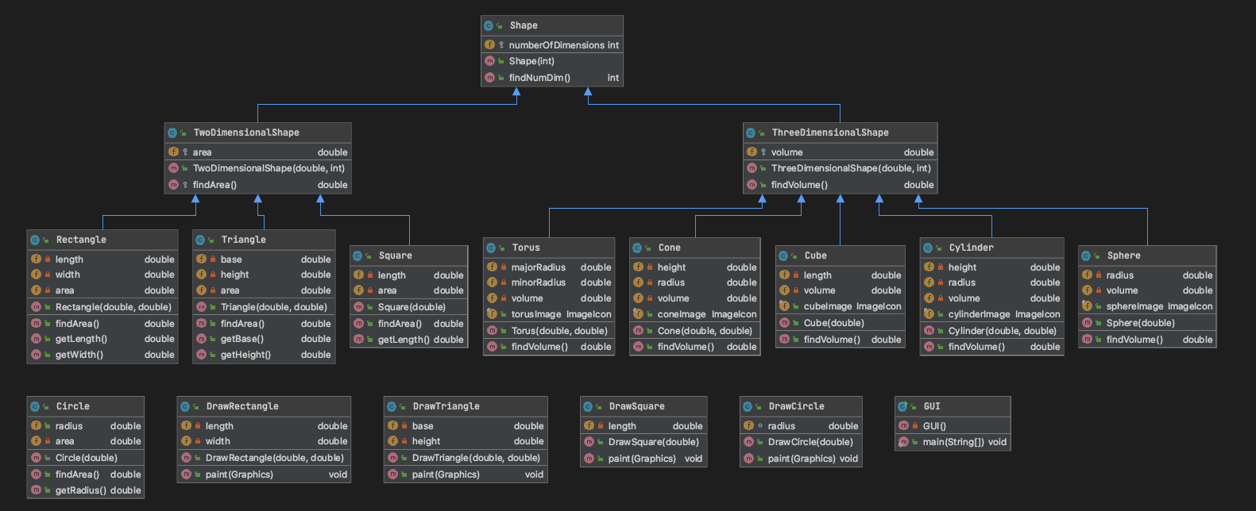

Figure UML Class Diagram for Shape Program

**Setup and Installation Guide**

Unpack the folder into a directory of your choice. Open the console or command prompt depending on your Operating system and navigate to the directory where the files were placed. Type “javac GUI.java” in the console to compile the Java code, and then type “java GUI” to run the program. Once in the program, select a shape to calculate the area or volume. Once a shape is selected, enter in the required input one digit at a time followed by the enter key, or enter both digits with a space in-between. To exit the program, enter input “10” from the main menu.

**Lessons Learned**

This was very frustrating for the author in trying to figure out how to display an image. In previous projects, the author has always displayed an image using ImageIcon, with code along the lines of “ImageIcon img = new ImageIcon(“filename.jpg”). After hours of research and frustration, the author figured out that now one must use “ImageIcon img = new ImageIcon(getClass().getResources(“filename.jpg)) for Java to properly display the image. Additionally, figuring out how to draw the two-dimensional objects was a challenge. The author ended up making separate classes for each two-dimensional shape to handle the drawing of the shape.

**Test Plan**

|  |  |  |  |
| --- | --- | --- | --- |
| **Test Case** | **Input** | **Expected Output** | **Pass/Fail** |
| 1 | Circle, 500 | Black colored circle to scale | Pass |
| 2 | Circle, 50 | Black colored circle to scale | Pass |
| 3 | Square, 150 | Black colored square to scale | Pass |
| 4 | Rectangle, 400, 650 | Black colored rectangle to scale | Pass |
| 5 | Cone, 5, 4 | Image of cone | Pass |
| 6 | Torus, 560.54, 324.5 | Image of torus | Pass |
| 7 | Sphere, 560 | Image of sphere | Pass |
| 8 | Triangle, 350, 500 | Image of black triangle to scale | Pass |
| 9 | Rectangle, this | JOptionPane Error Message | Pass |
| 10 | Triangle, 650.456, 300.8765 | Triangle to scale | Pass |
| 11 | Cube, 20 | Image of cube | Pass |
| 12 | Cylinder, 34, 35 | Image of cylinder | Pass |

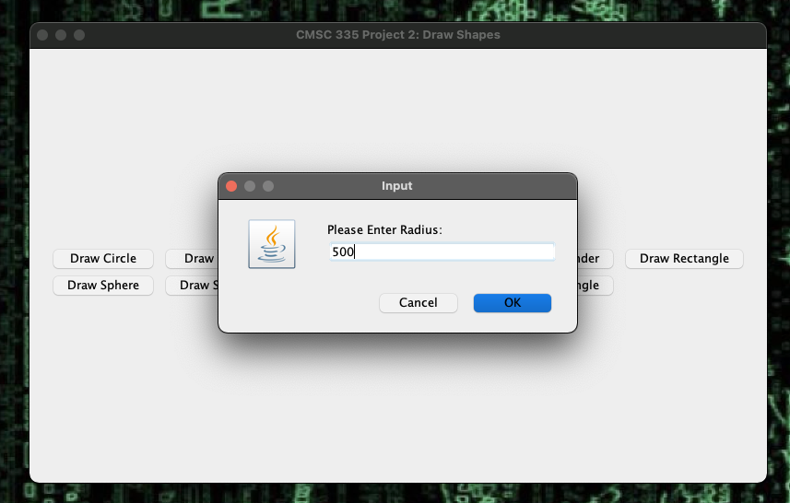

Figure Test Case 1

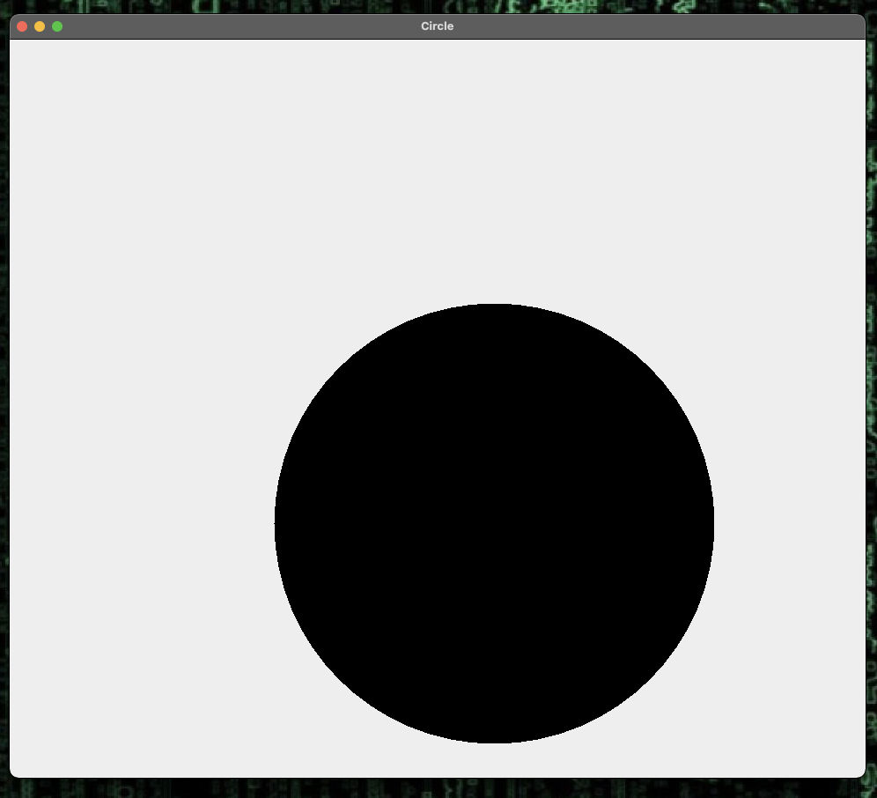

Figure Test Case 1

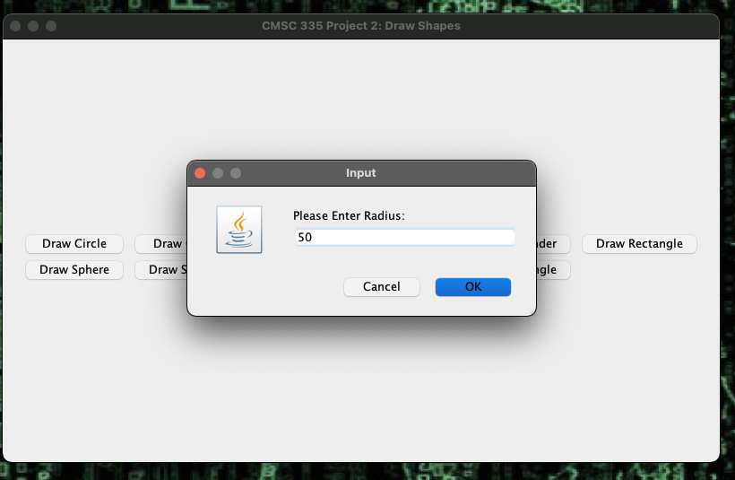

Figure Test Case 2

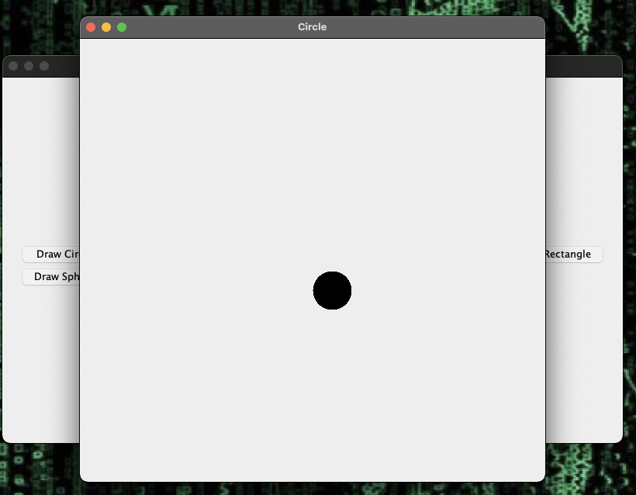

Figure Test Case 2

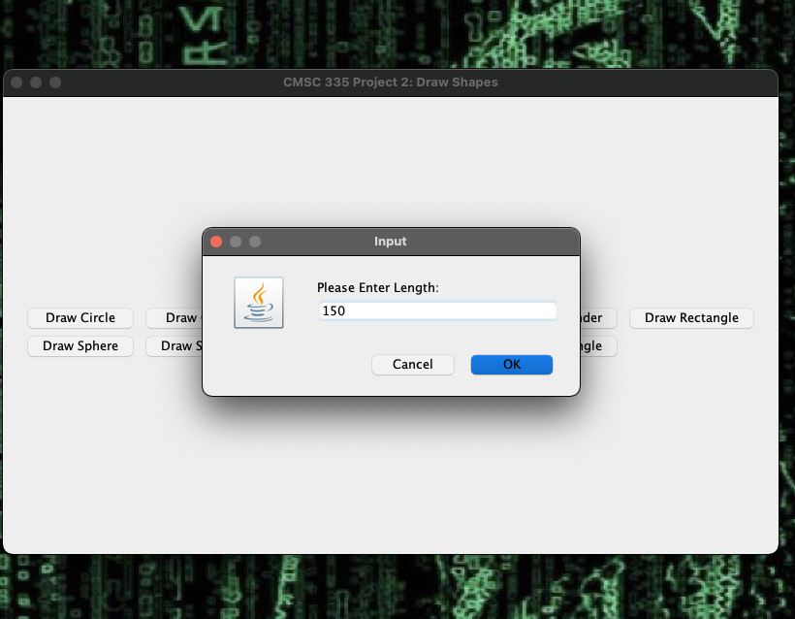

Figure Test Case 3

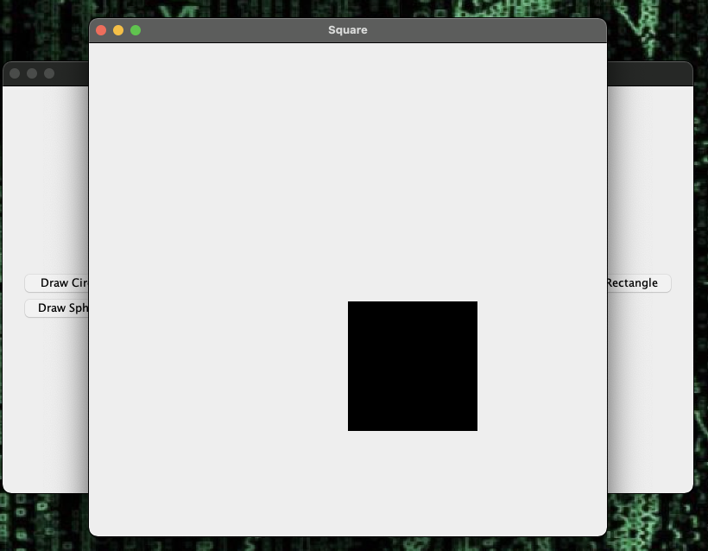

Figure Test Case 3

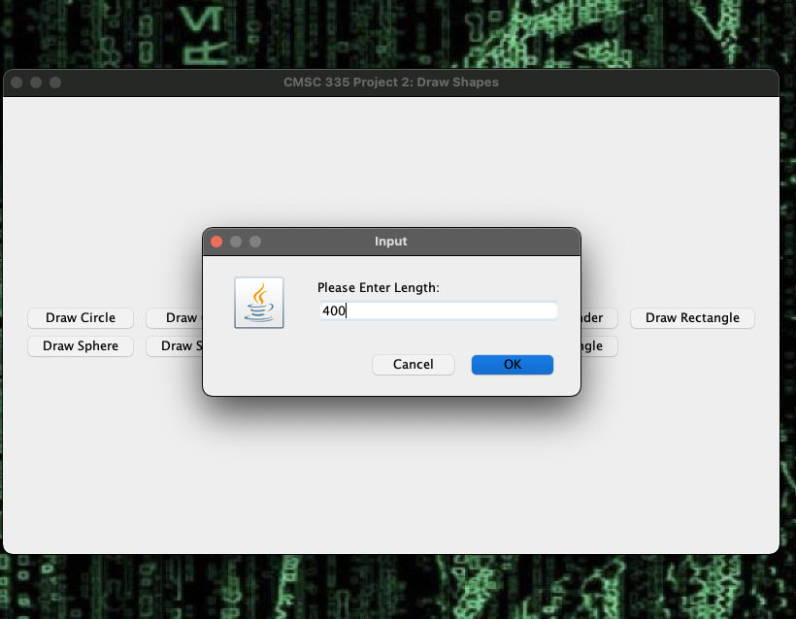

Figure Test Case 4

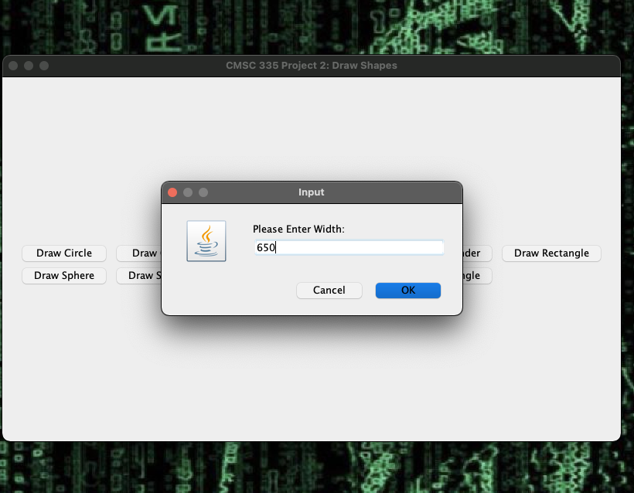

Figure Test Case 4

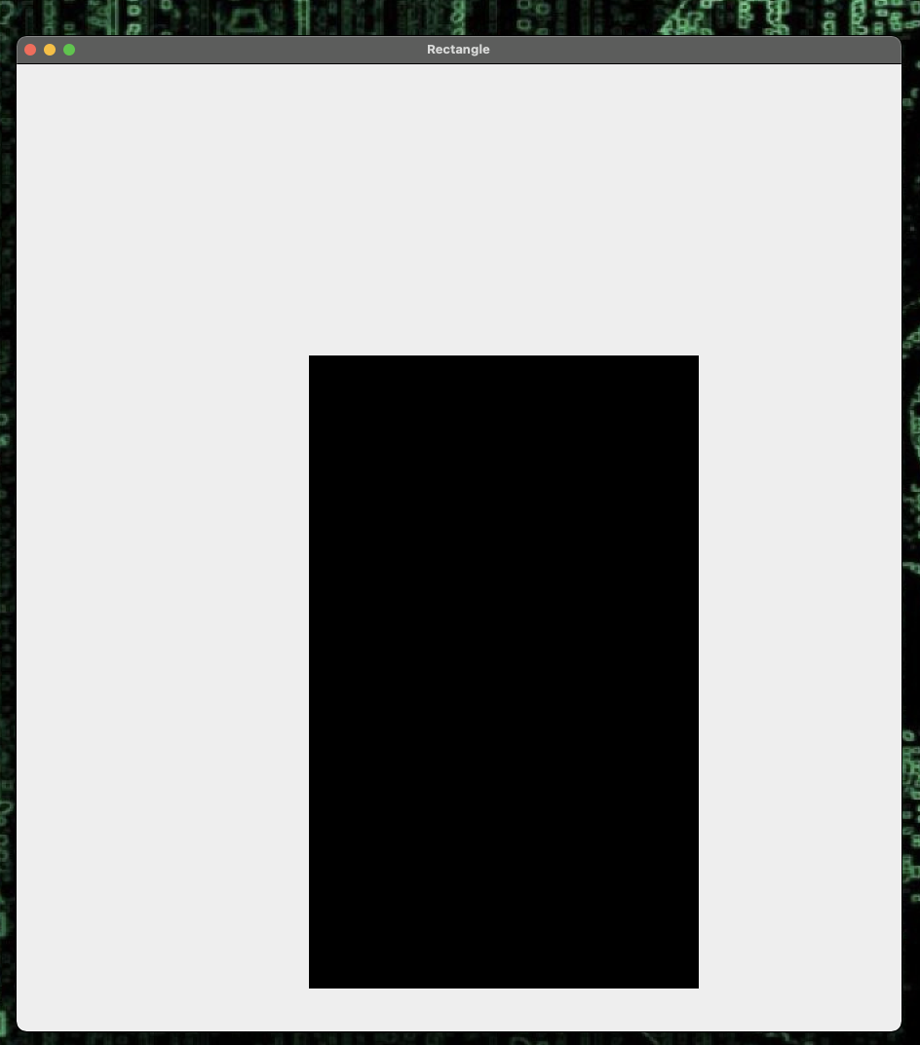

Figure Test Case 4

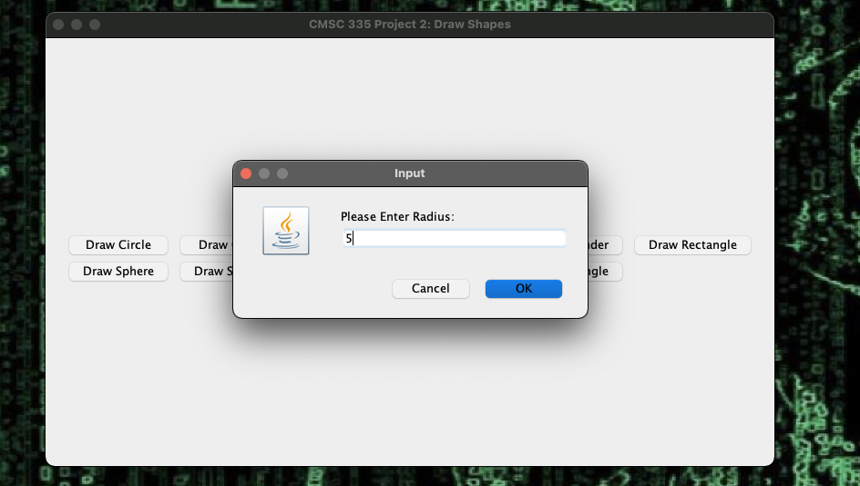

Figure Test Case 5

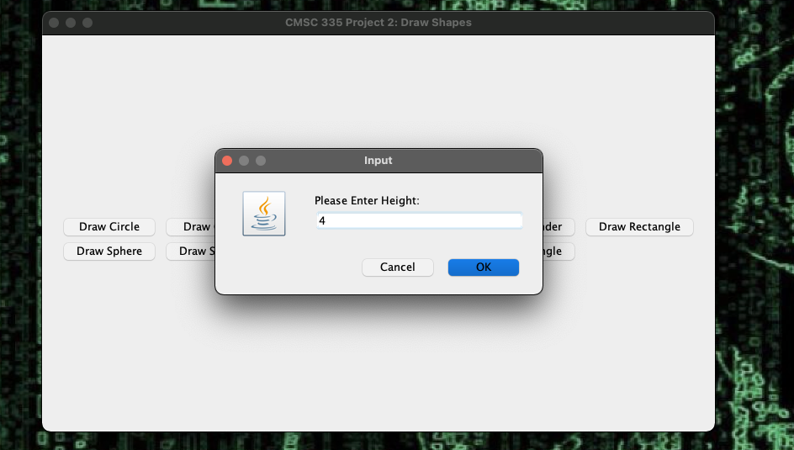

Figure Test Case 5

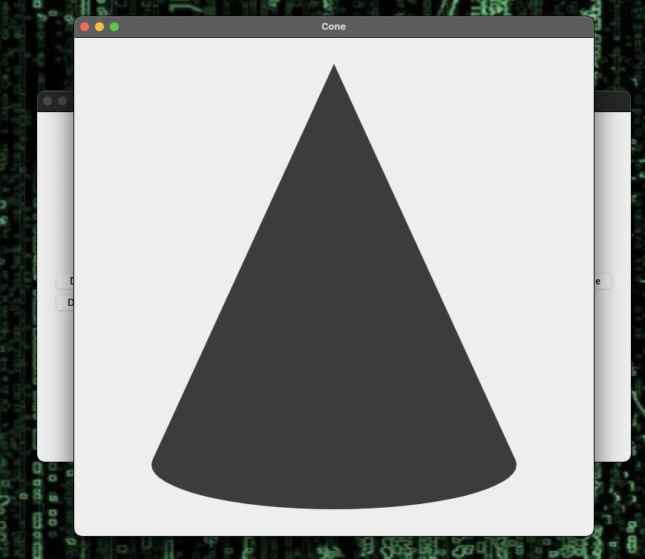

Figure Test Case 5

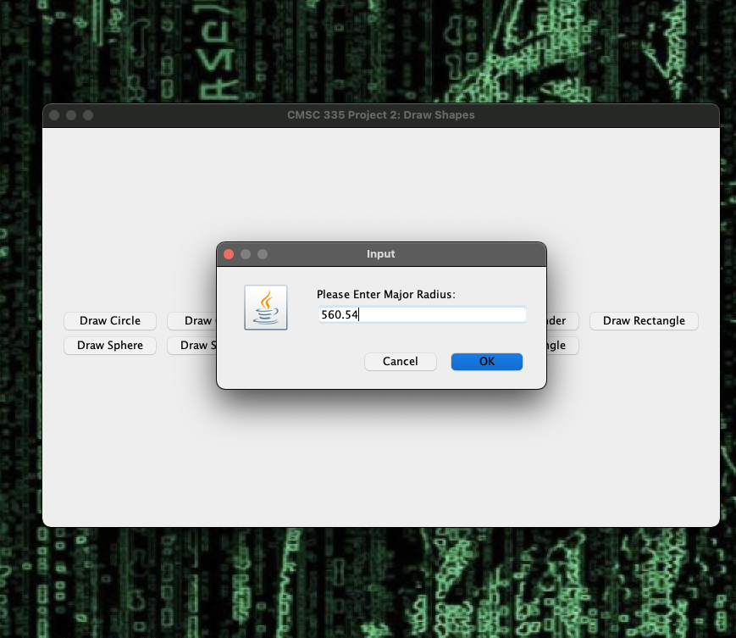

Figure Test Case 6

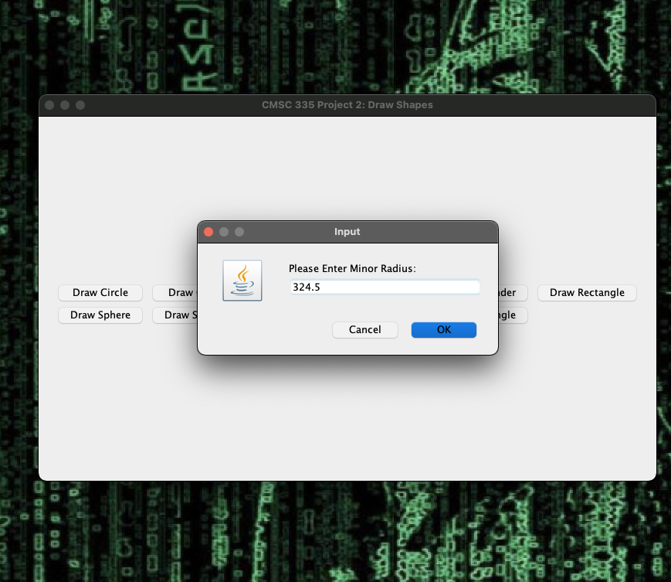

Figure Test Case 6

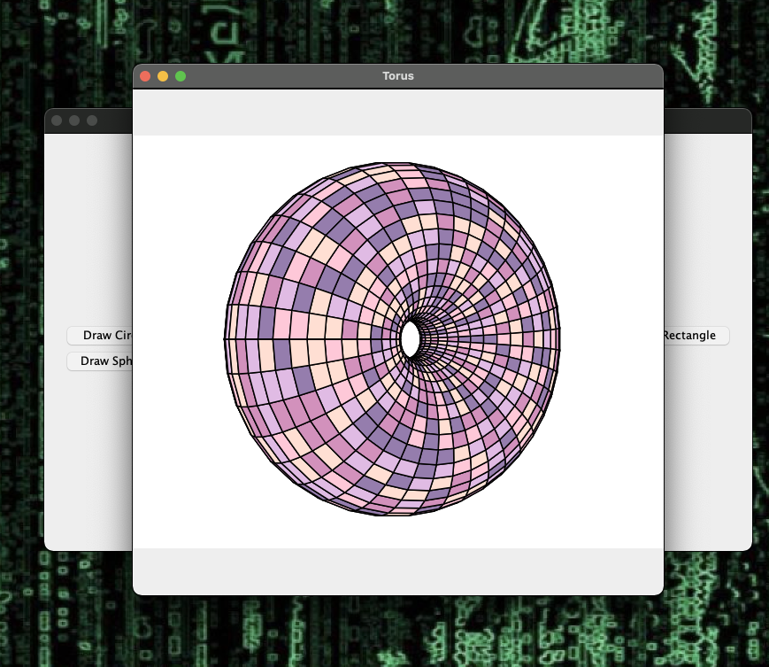

Figure Test Case 6

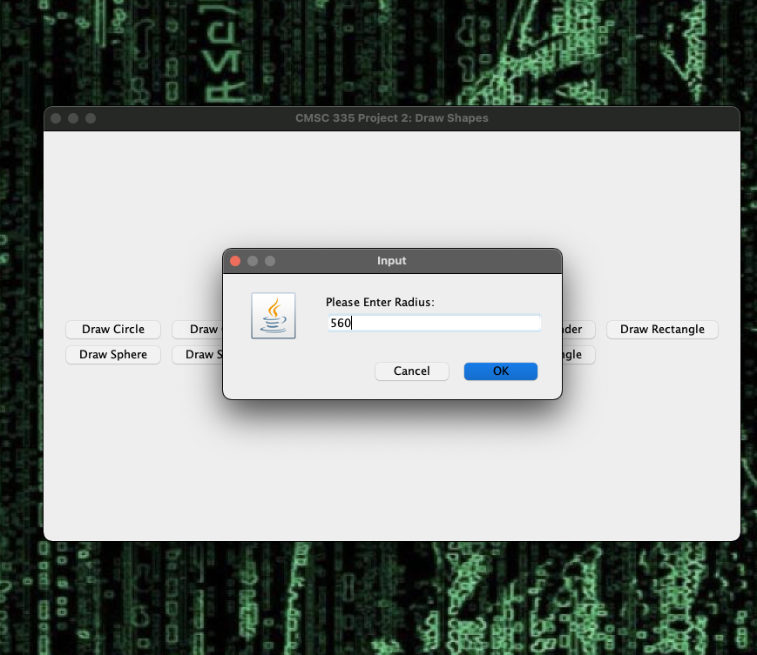

Figure Test Case 7

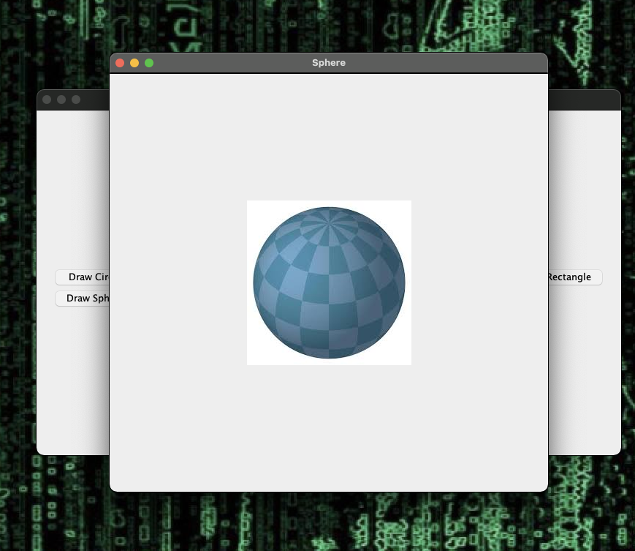

Figure Test Case 7

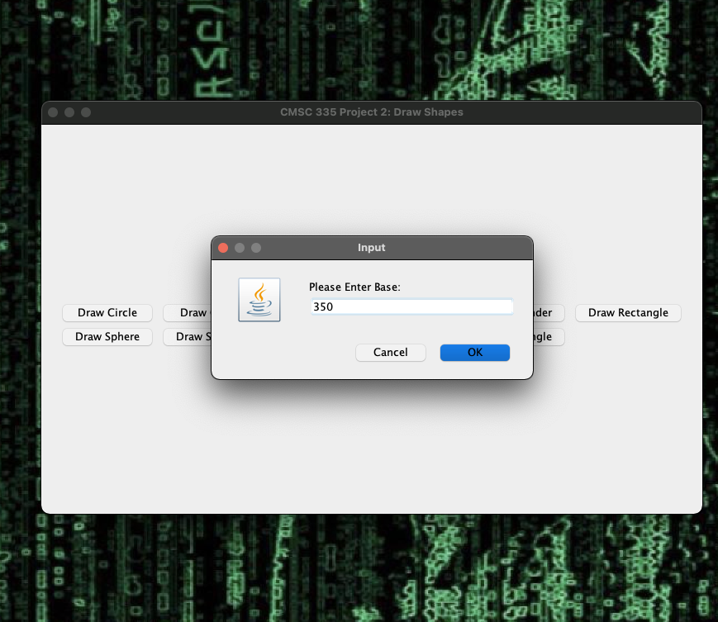

Figure Test Case 8

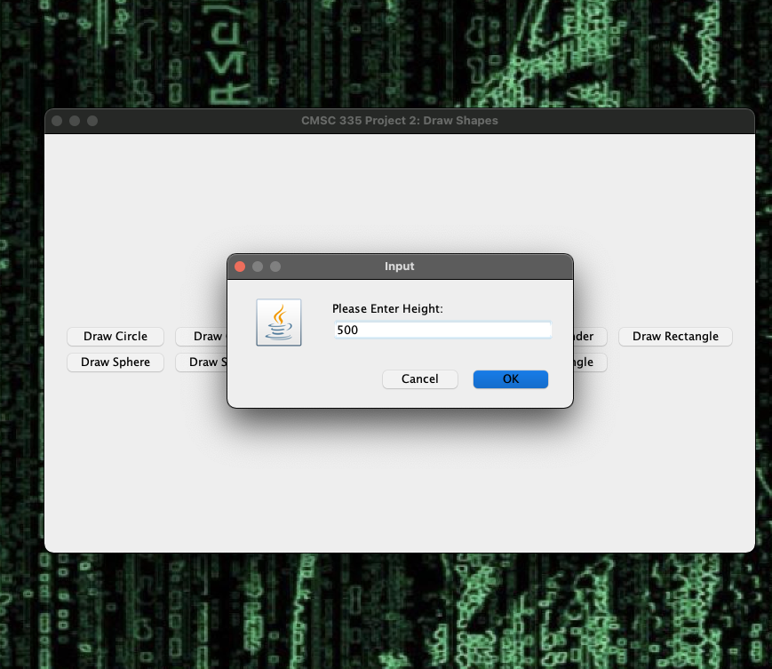

Figure Test Case 8

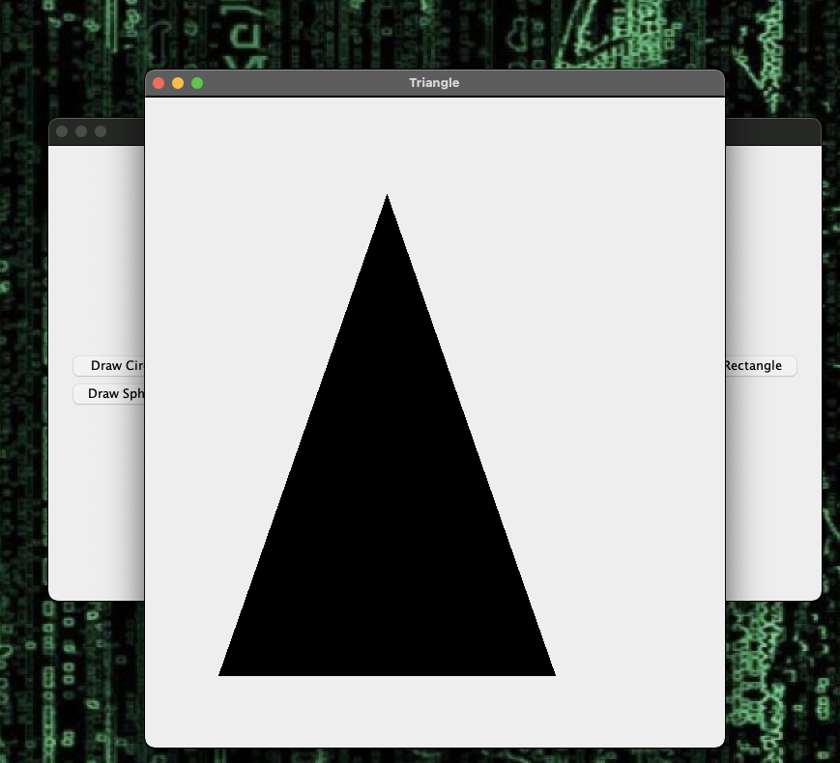

Figure Test Case 8

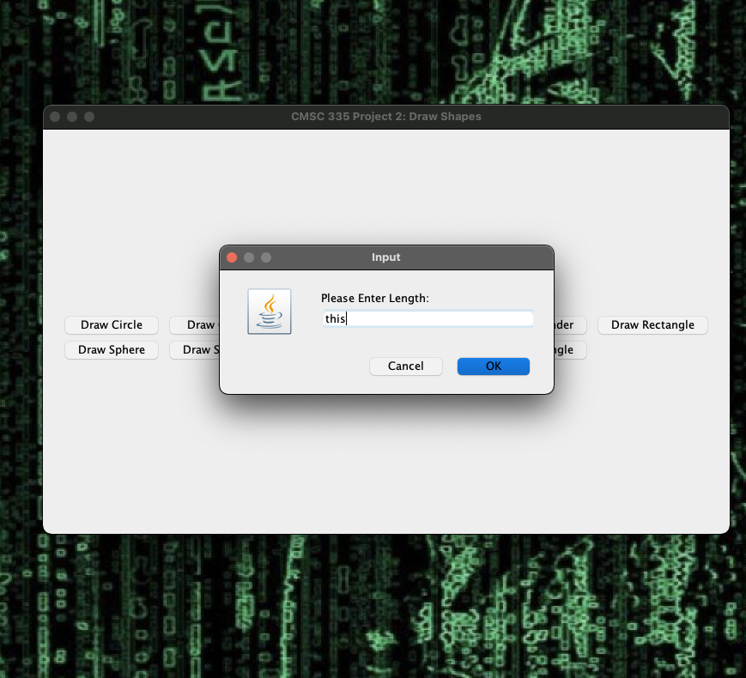

Figure Test Case 9

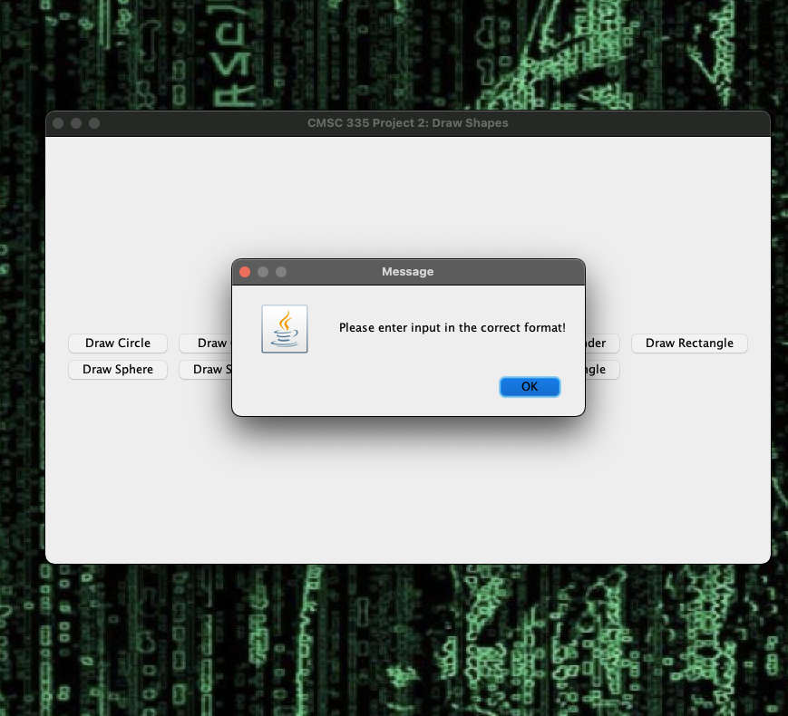

Figure Test Case 9

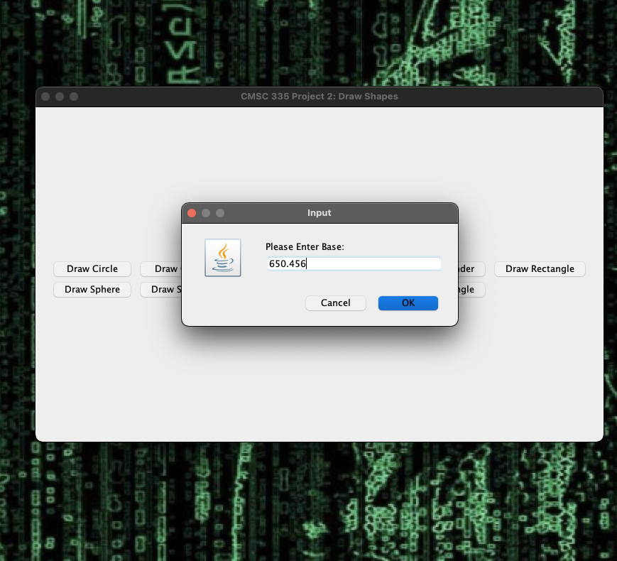

Figure Test Case 10

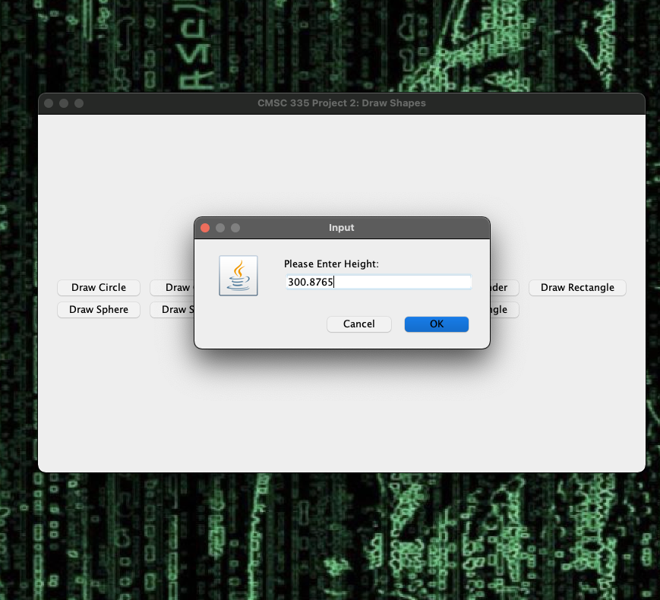

Figure Test Case 10

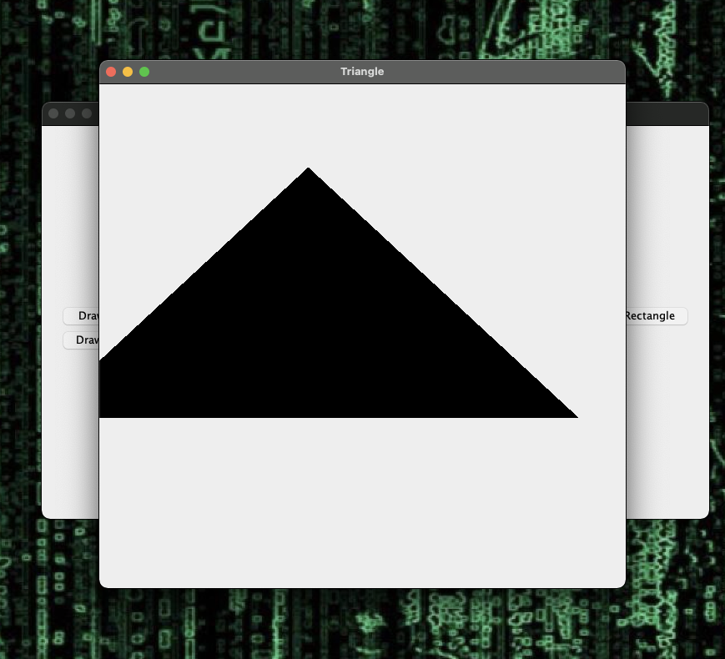

Figure Test Case 10

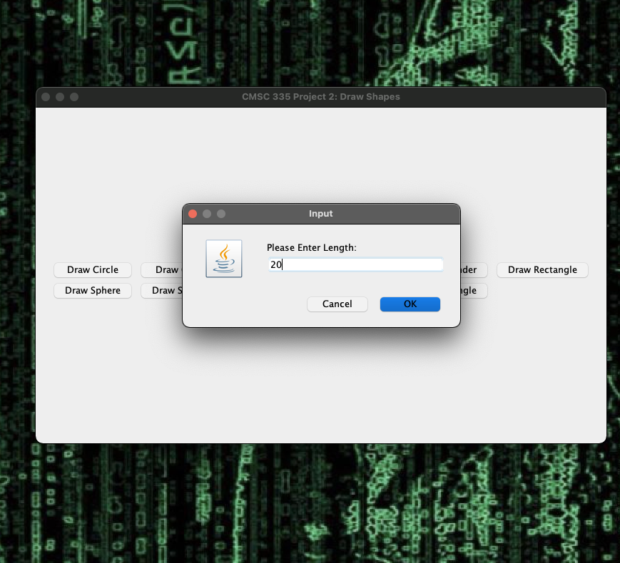

Figure Test Case 11

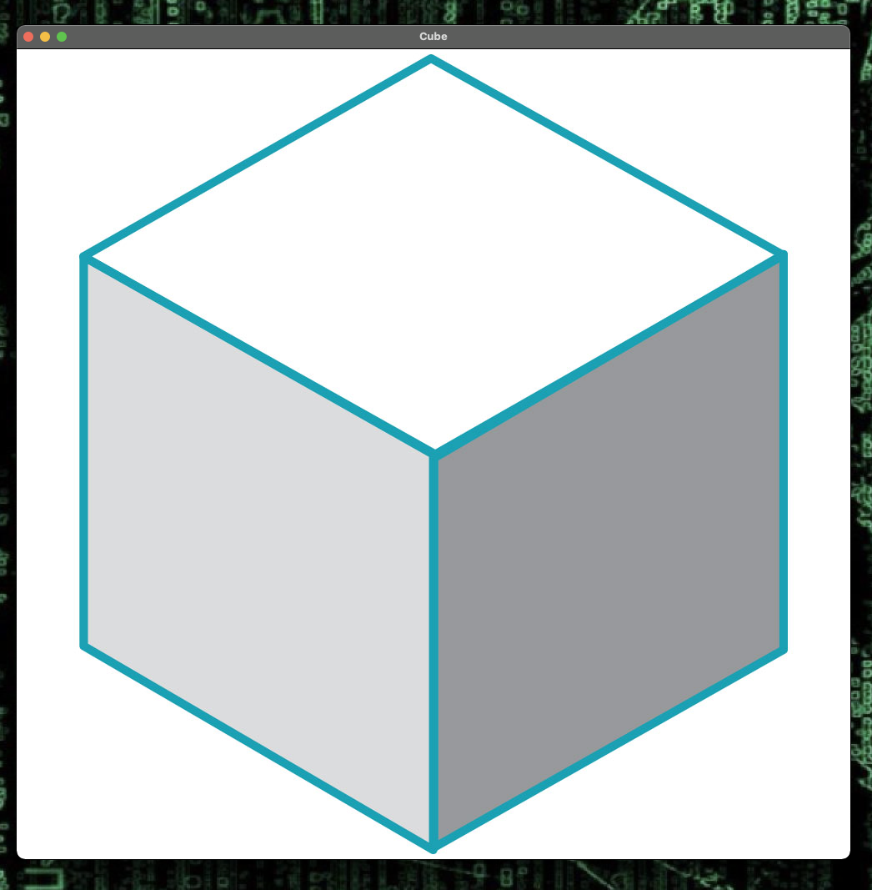

Figure Test Case 11

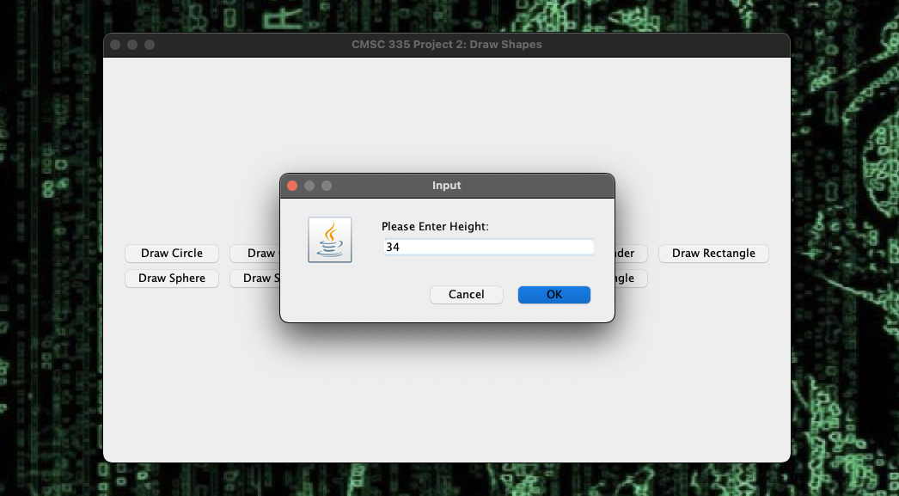

Figure Test Case 12

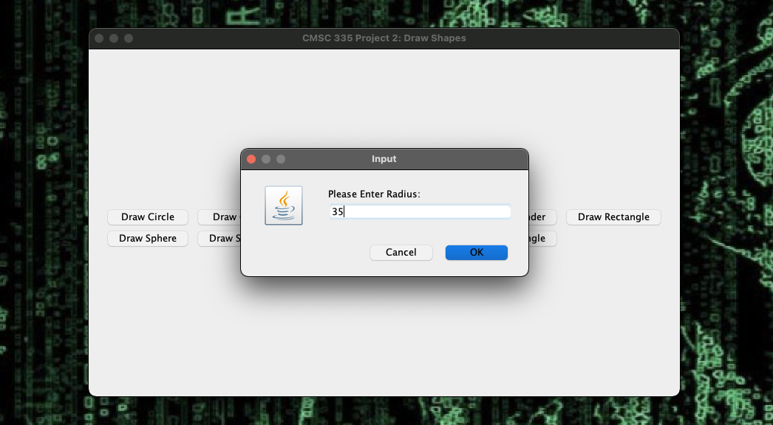

Figure Test Case 12

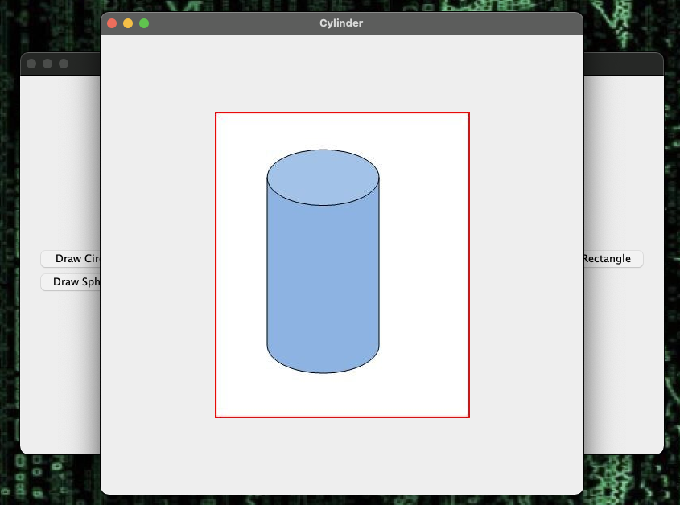

Figure Test Case 12